Total Loan Application
SELECT COUNT(DISTINCT(id)) FROM bank_loan_data;

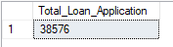

SELECT COUNT(id) as Decemeber_MoM FROM bank_loan_data
WHERE MONTH(issue_date) = 12 AND YEAR(issue_date) = 2021;

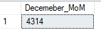
SELECT COUNT(id) as Loan_Application_PMTD FROM bank_loan_data
WHERE MONTH(issue_date) = 11 AND YEAR(issue_date) = 2021;
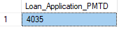

Total Funded Amount
SELECT SUM(loan_amount) as Total_Funded_Amount FROM bank_loan_data;

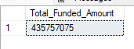

SELECT SUM(loan_amount) as Total_Funded_Amount FROM bank_loan_data
WHERE MONTH(issue_date) = 12;

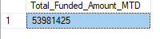

SELECT SUM(loan_amount) as Total_Funded_Amount_PMTD
FROM bank_loan_data
WHERE MONTH(issue_date) = 11;

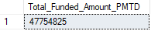

Total Amount Received
SELECT SUM(total_payment) as Total_Amount_Received
FROM bank_loan_data;
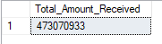

SELECT SUM(total_payment) as Total_Amount_Received_MTD
FROM bank_loan_data
WHERE MONTH(issue_date) = 12;

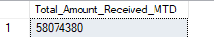

SELECT SUM(total_payment) as Total_Amount_Received_PMTD
FROM bank_loan_data
WHERE MONTH(issue_date) = 11;

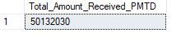

Average Interest Rate
*100 to get it in percentage
SELECT ROUND(AVG(int_rate),4) as Average_Interest_Rate
FROM bank_loan_data;

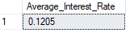
SELECT ROUND(AVG(int_rate),4) as Average_Interest_Rate_MTD
FROM bank_loan_data
WHERE MONTH(issue_date) = 12;

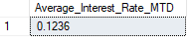
SELECT ROUND(AVG(int_rate),4) as Average_Interest_Rate_PMTD
FROM bank_loan_data
WHERE MONTH(issue_date) = 11;

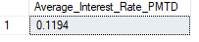

Average DTI
SELECT ROUND(AVG(dti),4) as Average_DTI
FROM bank_loan_data;

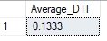
SELECT ROUND(AVG(dti),4) as Avg_DTI_MTD
FROM bank_loan_data
WHERE MONTH(issue_date) = 12;

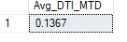
SELECT ROUND(AVG(dti),4) as Avg_DTI_PMTD
FROM bank_loan_data
WHERE MONTH(issue_date) = 11;

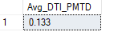

Good Loans
SELECT COUNT(id) AS good_loans
FROM bank_loan_data
WHERE loan_status = 'Fully Paid' OR loan_status = 'Current';

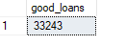
SELECT
(COUNT(CASE WHEN loan_status = 'Fully Paid' OR loan_status = 'Current' THEN id END)*100)
/COUNT(id) as good_loan_perc
FROM bank_loan_data;

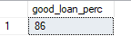
SELECT SUM(loan_amount) AS good_loan_fund_amount
FROM bank_loan_data
WHERE loan_status = 'Fully Paid' OR loan_status = 'Current';

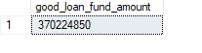
SELECT SUM(total_payment) AS good_loan_payment_amount
FROM bank_loan_data
WHERE loan_status = 'Fully Paid' OR loan_status = 'Current';

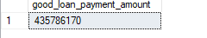

Bad Loan
SELECT COUNT(id) as bad_loan_count FROM bank_loan_data
WHERE loan_status = 'Charged Off';
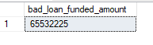

SELECT (COUNT(CASE WHEN loan_status = 'Charged Off' THEN id END)*100.0)
/
COUNT(id) as bad_loan_percentage
FROM bank_loan_data;
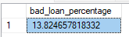

SELECT SUM(total_payment) as bad_loan_payment FROM bank_loan_data
WHERE loan_status = 'Charged Off';

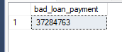
Loan Status Grid
SELECT loan_status,
COUNT(id) as loan_count,
SUM(loan_amount) as loan_amount_funded,
SUM(total_payment) as loan_payment_back,
AVG(int_rate)*100 as interest_rate_perc,
AVG(dti)*100 as dti_perc
FROM bank_loan_data
GROUP BY loan_status;

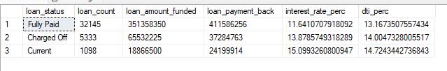

Monthly Trends by Issue Date
SELECT MONTH(issue_date) as monthly_trend,
COUNT(id) as Total_Loan_Count,
SUM(loan_amount) as Total_Funded_Amount,
SUM(total_Payment) as Total_Amount_Received
FROM bank_loan_data
GROUP BY MONTH(issue_date)
ORDER BY monthly_trend;

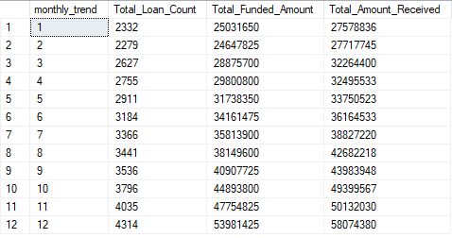

Regional Analysis by State
SELECT address_state as State_Name,
COUNT(id) as Total_Loan_Count,
SUM(loan_amount) as Total_Funded_Amount,
SUM(total_Payment) as Total_Amount_Received
FROM bank_loan_data
GROUP BY address_state;

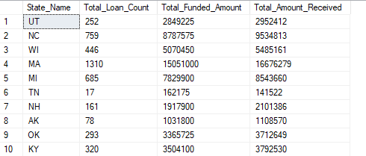

Loan Term Analysis
SELECT term as Loan_Duration,
COUNT(id) as Total_Loan_Count,
SUM(loan_amount) as Total_Funded_Amount,
SUM(total_Payment) as Total_Amount_Received
FROM bank_loan_data
GROUP BY term;
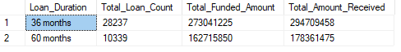

Employment Term Analysis
SELECT emp_length as Employment_Duration,
COUNT(id) as Total_Loan_Count,
SUM(loan_amount) as Total_Funded_Amount,
SUM(total_Payment) as Total_Amount_Received
FROM bank_loan_data
GROUP BY emp_length;
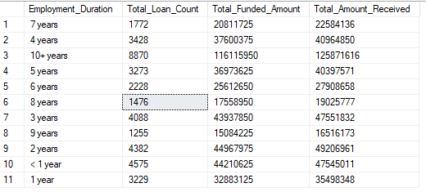

Loan Purpose Breakdown

SELECT purpose,
COUNT(id) as Total_Loan_Count,
SUM(loan_amount) as Total_Funded_Amount,
SUM(total_Payment) as Total_Amount_Received
FROM bank_loan_data
GROUP BY purpose
ORDER BY COUNT(id) DESC;

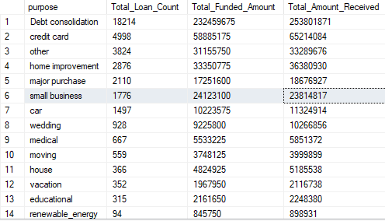

Home ownership analysis
SELECT home_ownership,
COUNT(id) as Total_Loan_Count,
SUM(loan_amount) as Total_Funded_Amount,
SUM(total_Payment) as Total_Amount_Received
FROM bank_loan_data
GROUP BY home_ownership
ORDER BY COUNT(id) DESC;

